Eugene Anisimov  Cpt.SOLO  AI Content & Visual Director · Fine Arts–Trained Photographer · Full-Stack Developer  Email: theeuge71@gmail.com  Web: cptsl.space  LinkedIn: linkedin.com/in/eugenanissimow  Portfolio: cptsl.space/work | 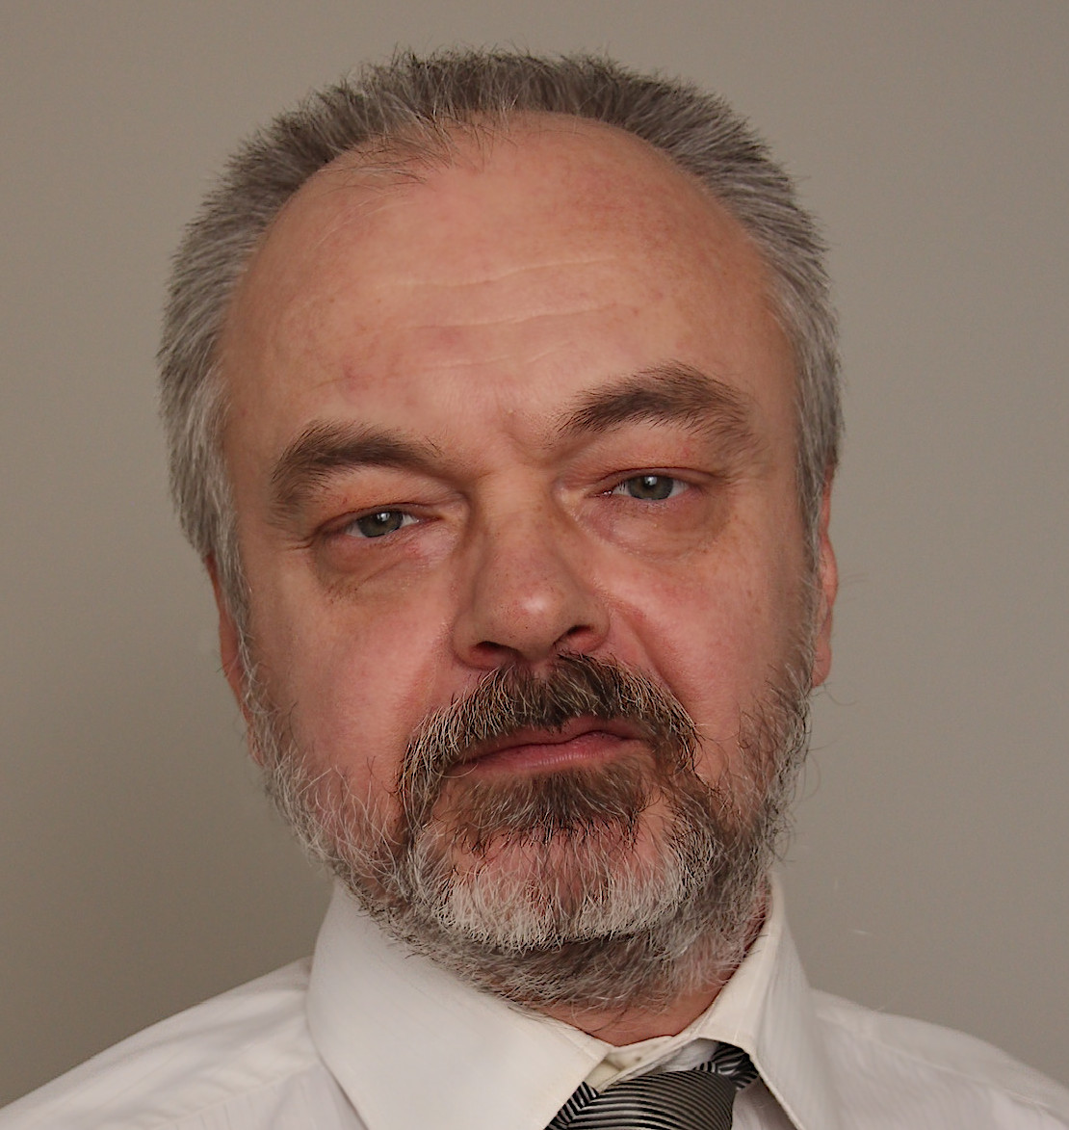

SUMMARY
Fine arts–educated photographer and art director with 30+ years in visual craft and 15+ years in full-stack development. I lead product-oriented image and video pipelines through my own integrated workflow for maximum photorealism — fine arts science, photography and cinematography craft, ComfyUI, product and style LoRA training, hybrid capture, post-production, and campaign delivery — as one accountable senior lead. Marketing director and head of business development experience keeps creative tied to commercial outcomes.
CORE CAPABILITIES
- Product visual systems & photoreal stills
- Cinematic video, edit, grade & social cut-downs
- AI content creation & creative direction
- ComfyUI workflows & LoRA training — product, character, style
- Image & video post-production at scale
- Full-stack web, WebGL & campaign sites
- Marketing strategy & sales-enablement alignment
OPEN TO
- AI Content Director
- Generative Visual Director
- Creative Director — AI-native campaigns
- Senior lead — product imagery & video pipelines
- Full-Stack full-cycle Frontend Development
- Freelance / project / embedded director roles
EXPERIENCE
AI Content & Visual Director Today
Independent — Cpt.SOLO
- Lead product-oriented image and video generation pipelines for brands and studios.
- ComfyUI workflow design — product LoRAs, consistent character LoRAs, style LoRAs, model training & tuning.
- Art direction, hybrid capture, post-production, QC, and campaign delivery.
- Open to AI content creation and direction roles — agency, brand, and platform teams.
Full-Stack Developer 15+ years
Independent & client engagements
- JavaScript, TypeScript, Vue, React, Next, Angular, Nuxt, WebGL — front-end and back-end.
- Campaign sites and interactive experiences from zero through deployment and maintenance.
- Same lead who directs visuals ships the live destination when campaigns require it.
Art Director · Marketing Director · Head of Business Development Leadership
Commercial & creative leadership
- Shaped how visuals connect to launch, promotion, and sales across channels.
- Aligned creative decisions with channel reality and commercial goals from the start.
- Stakeholder fluency across brand, marketing, and sales teams.
Photographer · Video Director · Art Director 30+ years
Professional practice
- Product-oriented imagery, cinematic video, and art direction at photoreal standard.
- Fine arts training applied to composition, color, form, and material sensitivity.
- From darkroom and film through digital cinema and hybrid generative pipelines.
SELECTED WORK
Luxury Product Visual System 2025
Confidential — Beauty & Lifestyle · 48 assets · 2-week turnaround · no studio rental
Photoreal product stills and lifestyle compositions delivered without a physical shoot — consistent art direction across 48 assets.
Cinematic Product Film 2025
Confidential — Technology · Directed shoot · 1 hero film · 6 cut-downs · 12 stills
On-set commercial product film — directed capture, macro motion, and broadcast-grade grade. Not AI-generated: real light, lens, and editorial craft.
Commercial Product Photography 2024
Confidential — Consumer Goods · Directed shoot · 32 finals · pack, hero & lifestyle
Studio and location product photography — pack shots, hero stills, and lifestyle frames from directed commercial shoots. Real capture, fine-arts lighting, and precision post.
Campaign Site & Asset Platform 2024
Confidential — Retail · Visual system + live site · sole lead · 3 weeks
Integrated campaign: visual system, responsive launch site, and deployment — sole lead from concept through maintenance.
LunarTrek 2025
Personal project — Cpt.SOLO · Original IP · solo dev · sci-fi simulation
Sci-fi trucking simulation set on the Moon — haul cargo across lunar routes, manage your rig, and survive the harsh frontier. Original IP conceived, designed, and built solo.
AI Mixed Media — Video & Music 2025
Personal project — Cpt.SOLO · AI image · video · music · orchestrated master
Personal audio-visual piece — AI-generated image, video, and music edited, processed, and orchestrated into a single mixed-media work.
TECH STACK
Visual & post
Fine arts & photography · Art direction · Product stills & lifestyle · Cinematic video · Edit & composite · Color grade · Retouch & QC · Sound direction & mix
AI & generative
ComfyUI workflows · Product LoRA training · Consistent character LoRAs · Style LoRA development · Model training & tuning · AI image & video generation · Hybrid capture pipelines · ML · Mixed-media orchestration
Languages & data
JavaScript · TypeScript · Java · PHP · Python / Pandas · MySQL · Solidity
Frontend
Vue.js · React.js · Next.js · Angular.js · Nuxt · Tailwind CSS
Backend & platforms
Laravel · Node.js · REST APIs · Firebase · WordPress — development & customization
3D & interactive
Three.js · PlayCanvas.js · WebGL
Deploy & delivery
Vercel · Performance optimization · Analytics · Production maintenance · Campaign sites · Interactive experiences
EDUCATION
Fine Arts & Photography Education
Professional artistic education in fine arts with dedicated study and practice in photography — composition, color theory, form, and visual literacy.

